**Facilitated Activity: Social Media Fact Check (15-20 minutes)**

Adapted from this exercise: <http://mediashift.org/2015/06/remix-teaching-students-to-verify-social-media-content/>

**Objective:**

This exercise allows participants to critically consider social media posts and get hands-on experience verifying photos.

**Materials:**

1. If possible: Laptops or tablets, at least one for each group
2. Images printed as handouts, or on laptops/tablets

**Exercise:**

1. Divide participants into groups and give an example scenario that includes an image in its posted context.
2. Group members discuss how they would verify the information included in the scenario, then use computers, tablets, or their phones to actually fact-check the scenario. Most stories can be checked by Google searches and/or Reverse Google Image searches. (5-10 minutes)
3. Come back together and have each group share their findings, and what tactics they used to find the story. (10 minutes)

Note: If people have seen the images before, ask them not to spoil it for others! People should still be encouraged to carry out the exercise.

**Sample Images:**



Story: <https://www.buzzfeed.com/kassycho/make-them-billionaires-buy-their-album?utm_term=.vuvXJmgXZN#.cmv4kMP4qe>

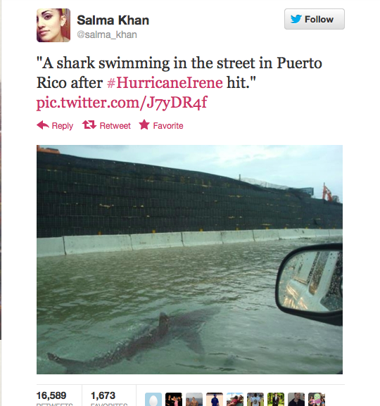

Story:

<https://mashable.com/2017/09/12/hurricane-shark-fake/#4h7jvAlwbOqG>

**PAUL MCCARTNEY HANGS OUT AT LOCAL TRUCKING COMPANY**

Mike Sims posted this photo on the Facebook page of CNY Central (Syracuse). Sims claimed Paul McCartney (yes, Sir McCartney, of Beatles fame!) stopped by NEMF Trucking in East Syracuse.

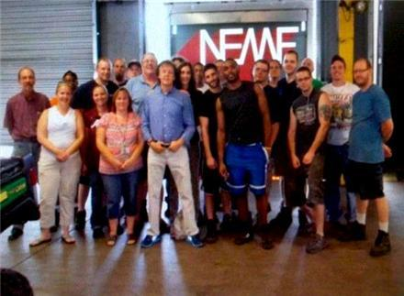

Story: <http://gothamist.com/2012/09/07/paul_mccartney_visits_upstate_truck.php>

**Giant Sinkhole!**

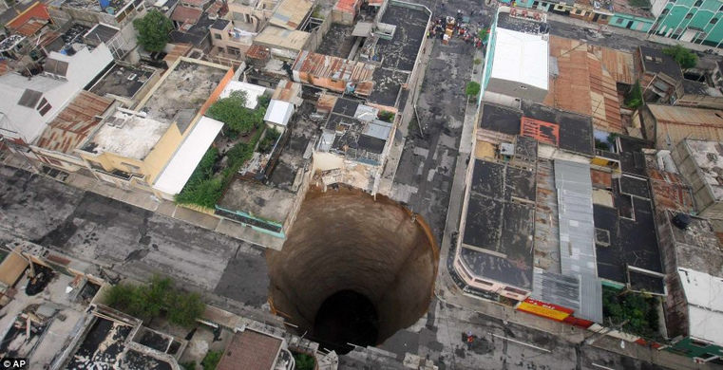

Story:

<https://news.nationalgeographic.com/news/2010/06/100603-science-guatemala-sinkhole-2010-humans-caused/>

<https://www.atlasobscura.com/places/the-great-guatemalan-sinkhole>

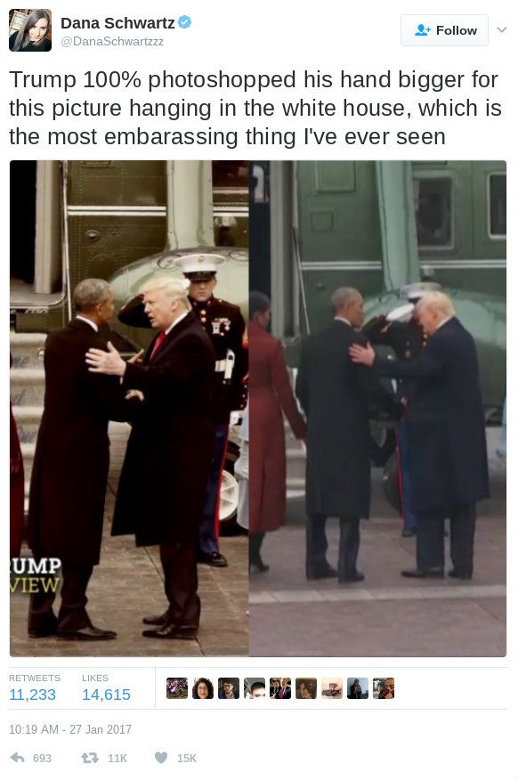

Story: <https://www.snopes.com/trump-photoshopped-hands/>



Story: <https://www.snopes.com/baby-born-holding-iud/>